**上机实践7：内部类与异常类**

**一、实验目的**

1. 掌握内部类与外嵌类的概念。
2. 掌握使用try-catch语句。

**二、实验内容及步骤**

**实验1 内部购物券 手机专卖店为促销自己的产口，决定发行内部购物券，但其他商场不能发行该购物券。编程进行模拟。**

程序：

**package** example1;

**class** MobileShop{

InnerPurchaseMoney purchaseMoney1;

InnerPurchaseMoney purchaseMoney2;

**private** **int** mobileAmount; //手机数量

MobileShop(){

purchaseMoney1 = **new** InnerPurchaseMoney(20000);

purchaseMoney2 = **new** InnerPurchaseMoney(10000);

}

**void** setMobileAmount(**int** m){

mobileAmount = m;

}

**int** getMobileAmount(){

**return** mobileAmount;

}

**class** InnerPurchaseMoney{

**int** moneyValue;

InnerPurchaseMoney(**int** m){

moneyValue = m;

}

**void** buyMobile(){

**if**(moneyValue >= 20000){

mobileAmount = mobileAmount -6;

System.***out***.println("用价值"+moneyValue+"内部优惠券买了6部手机");

}**else** **if**(moneyValue < 20000 && moneyValue >=10000){

mobileAmount = mobileAmount -3;

System.***out***.println("用价值"+moneyValue+"内部优惠券买了3部手机");

}

}

}

}

**public** **class** NewYear {

**public** **static** **void** main(String[] args) {

MobileShop shop = **new** MobileShop();

shop.setMobileAmount(30);

System.***out***.println("手机专卖店目前有"+shop.getMobileAmount()+"部手机");

shop.purchaseMoney1.buyMobile();

shop.purchaseMoney2.buyMobile();

System.***out***.println("手机专卖店目前有"+shop.getMobileAmount()+"部手机");

}

}

运行截图：

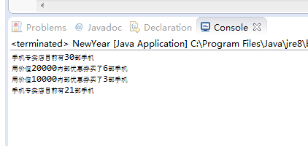

**实验2 检查危险品 车站检查危险品的设备，如果发现危险品会发出警告。编程模拟设备发现危险品。**

程序：

**package** example2;

**public** **class** Check {

**public** **static** **void** main(String[] args) {

Machine machine = **new** Machine();

String name[] = {"苹果","炸药","西服","硫酸","手表","硫磺"};

Goods [] goods = **new** Goods[name.length];

**for**(**int** i=0;i<name.length;i++){

goods[i] = **new** Goods();

**if**(i%2==0){

goods[i].setIsDanger(**false**);

goods[i].setName(name[i]);

}**else**{

goods[i].setIsDanger(**true**);

goods[i].setName(name[i]);

}

}

**for**(**int** i=0;i<goods.length;i++){

**try**{

machine.checkBag(goods[i]);

System.***out***.println(goods[i].getName()+"检查通过！");

}**catch**(DangerException e){

e.toShow();

System.***out***.println(goods[i].getName()+"被禁止！");

}

}

}

}

**package** example2;

**public** **class** DangerException **extends** Exception{

String message;

**public** DangerException(){

message = "危险品!";

}

**public** **void** toShow(){

System.***out***.println(message+"");

}

}

**package** example2;

**public** **class** Goods {

**boolean** isDanger;

String name;

**public** **void** setIsDanger(**boolean** boo){

isDanger = boo;

}

**public** **boolean** isDanger(){

**return** isDanger;

}

**public** **void** setName(String s){

name = s;

}

**public** String getName(){

**return** name;

}

}

**package** example2;

**public** **class** Machine {

**public** **void** checkBag(Goods goods) **throws** DangerException{

**if**(goods.isDanger){

DangerException danger = **new** DangerException();

**throw** danger;

}**else**{

System.***out***.println(goods.getName()+"不是危险品！");

}

}

}

运行截图：

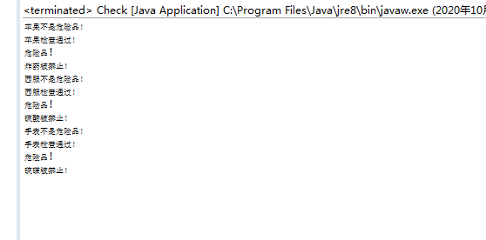

**三、实验小结**

掌握了内部类与外嵌类的概念。

掌握了使用try-catch语句。